Warning signs feature a black border on a yellow background, serving to alert vehicles and pedestrians to hazardous locations;
As the dataset contains warning road signs that exceed the broad definition of warning signs—not necessarily triangular in shape—these are also categorised as warning signs for statistical purposes.
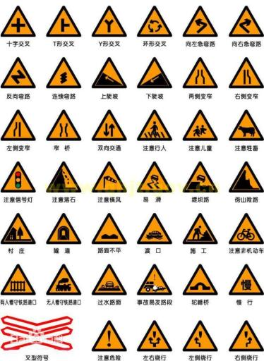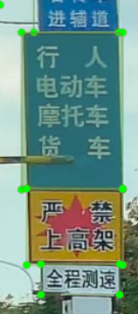
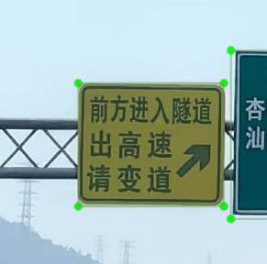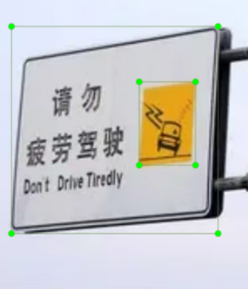

Prohibition signs, with the exception of certain specific signs, feature a white background, red border, red diagonal bar, and black symbol. Large prohibition signs: Prohibition signs are used to prohibit or restrict the movement of vehicles or pedestrians; for statistical purposes, red and white arrow signs are also categorised as prohibition signs.
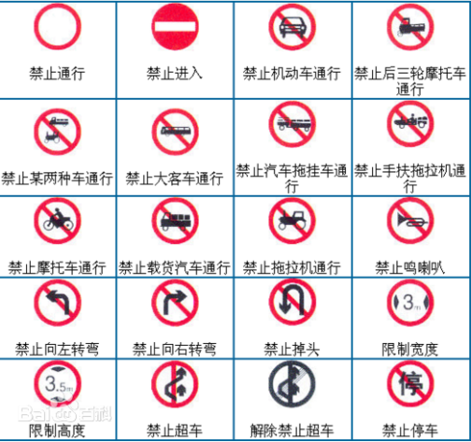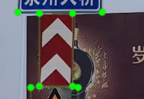

Indicator signs feature a blue background with white patterns and lettering, or a green background. Their shapes include circular, rectangular, and square.
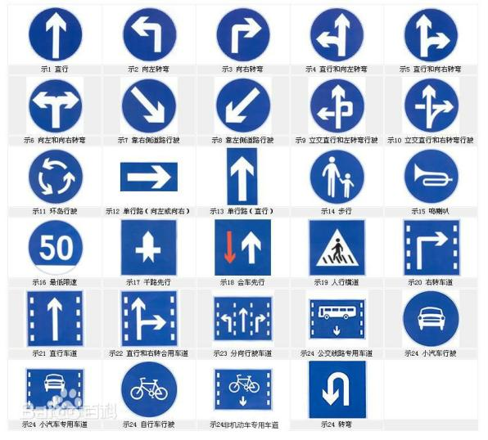

General colours for directional signs with text are blue backgrounds with white patterns and lettering, alongside green motorway and urban expressway directional signs, and brown tourist area signs. The primary criteria for identifying directional signs are the presence of place names, directional arrows, distance information, and road details.
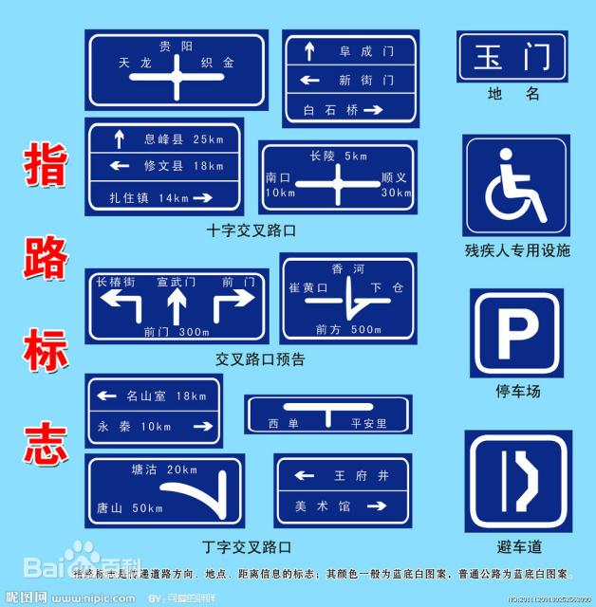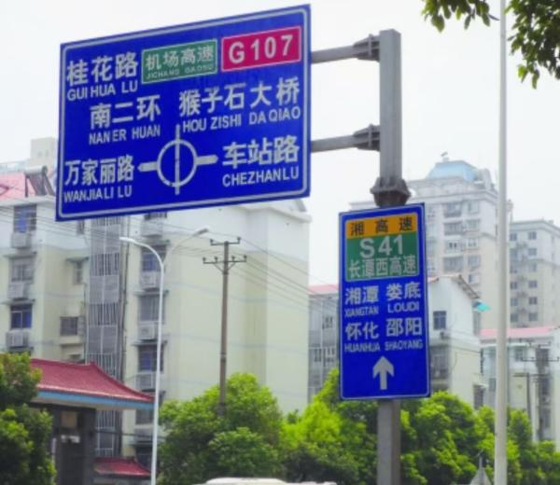
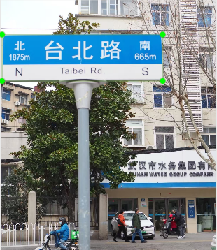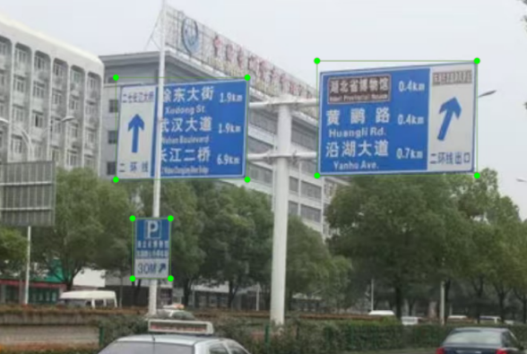
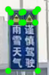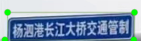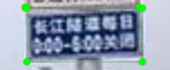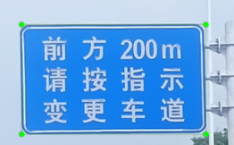

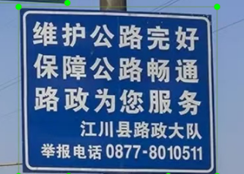
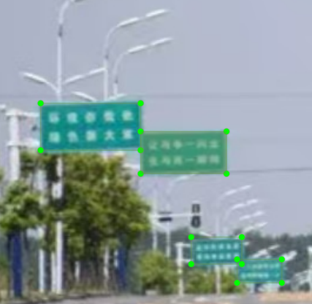
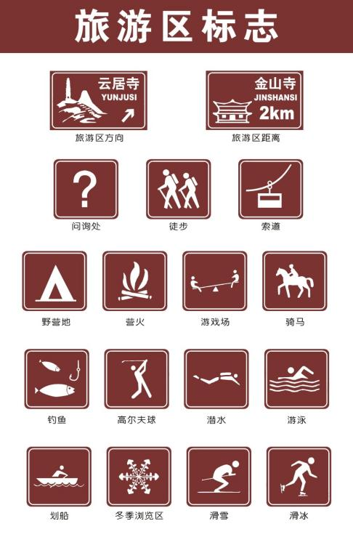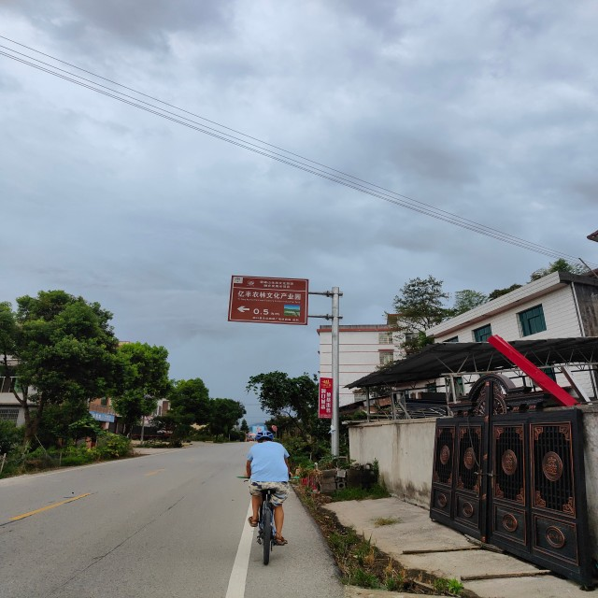
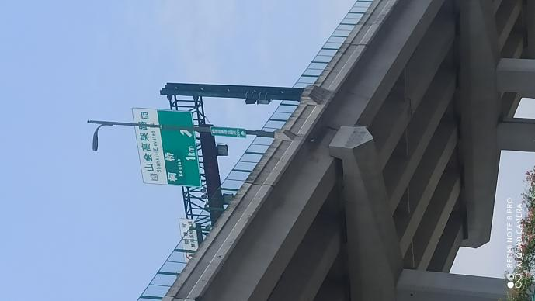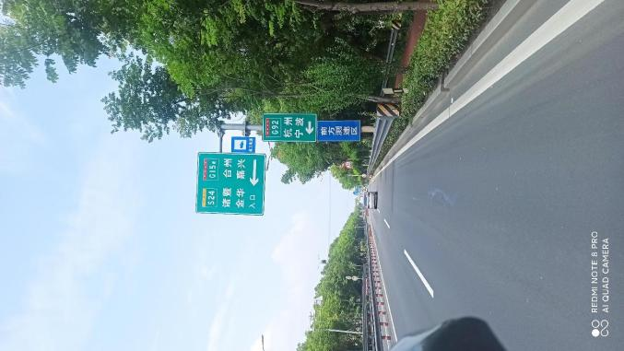

Supplementary signs are categorised by function into several types: those indicating time, vehicle categories, regional distances, warnings and reasons for prohibitions, as well as composite supplementary signs. They are rectangular in shape, featuring a white background with black text and black borders. In most instances, supplementary signs are integrated with primary signs to form a single road sign. For statistical purposes, all white-background road signs lacking directional or location indications are classified as supplementary signs.
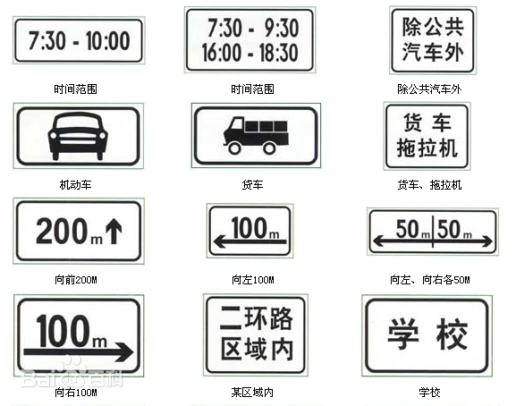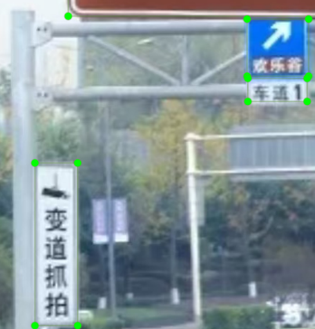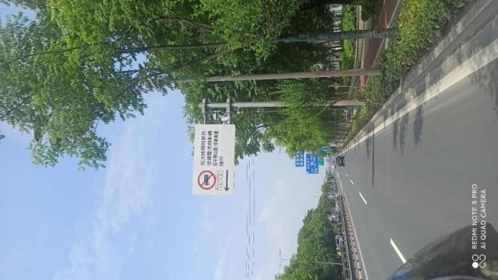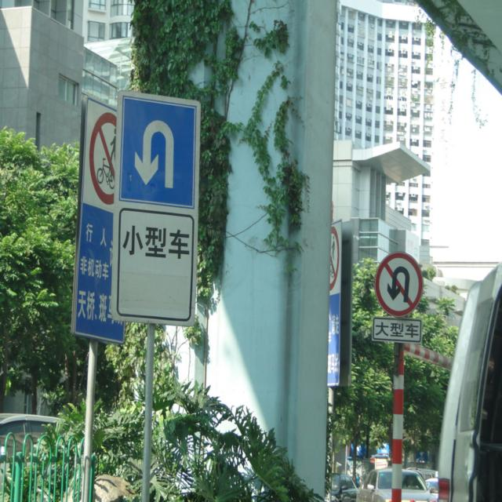
Additional Notes:
- Where other prohibitory signs appear on directional signs or supplementary signs, separately record and tally the number of such prohibitory signs.
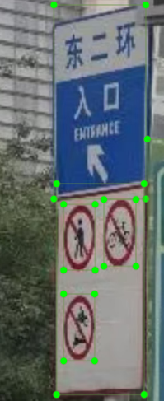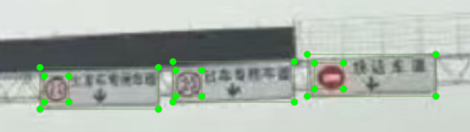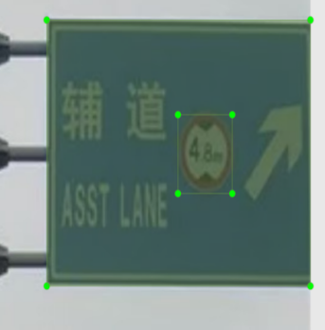
2. Some directional signs on motorways and ordinary roads display exit number information and should also be classified as directional signs.
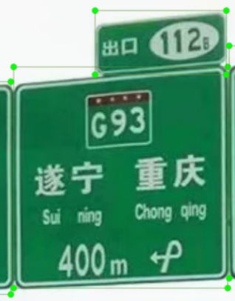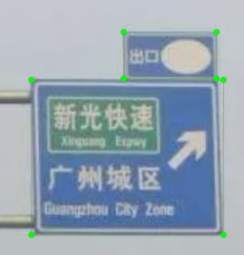

When annotating the dataset, the plan is as follows:
Yellow warning signs shall be annotated as 0
Red prohibition signs shall be annotated as 1
Blue-green-brown directional signs with text shall be annotated as 2
Blue-green regulatory signs shall be annotated as 3
White supplementary signs shall be annotated as 4
Category 0: 3,270
Category 1: 7,464
Category 2: 7,255
Category 3: 5,145
Category 4: 1,621

